**PROPOSAL PROJECT 2**

My artistic vision for this project is to make a mystery game where we acknowledge that the character (Tim) wakes up in the middle of a forest. He doesn’t know how he ended up there so with the help of the player, the character will have to deep dive into his memories to fill in the gaps and hopefully understand what happened to him. For the first part of the project, the situation will be explained in a dialogue the character is having with himself, like a vocal point of view of what he sees and what he is feeling when he is in the forest. He will then try his best to remember what happened by going back in his memories. The memories will be displaced in a 3D like environment where multiple memory boxes will be floating around ( See screenshot from prototype), there will be around 4 deep memories in which the player will have to find clues and answers to help Tim (the game is played as if the player IS Tim, but for the purpose of the explanation I will refer as Tim and the player as two different entities.) In order to access each memory, the player will have to click on each box to play or interpret each one of them. The memories can be played in any order, even if there is a chronological one.

Memory #1

Tim is walking home after work and on his way home he comes across a weird medallion. He picks it up and looks at it, takes it home. Once he gets home, he opens his computer and tries to do some research, but an error message appears on his screen.

Interactivity: the player makes Tim walk home, we hear the footsteps, and we see them on the path he is walking on (1). When he reaches the medallion the screen changes to a zoom of the medallion(2). The next scene is the computer screen, the challenge here will be to make the user write what the instructions tell him to write and to make the letters appear on the screen as the player is typing (3). Once the correct research is entered in the research motor of the computer, a big error message appears on the screen (4)

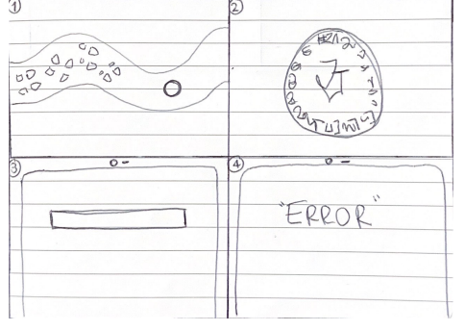

Memory #2

Tim comes home from work one day and sees that his stuff is not how he left it. He’s trying to figure out what is missing and once he does, he gets hit in the head and everything is blank from there.

Interactivity: the player will have to play the famous “what’s the difference between these images” game where he needs to find 5 differences from his home before he went to work and after he came back so we understand what is missing and possibly why. The two rooms will be side by side. Once the 5 differences are found, the screen turns black and we hear a big noise, Tim was hit.

Memory #3

Tim wakes up in a dark room where he can’t see anything, he still has his phone but no internet to call for help. He opens his flashlight to see where he is, it’s a basement with lots of weird things, he sees a weird document and decides to read through it. The same logo that was also on the medallion appears on the documents. It looks like it’s a sect of some sort where they sacrifice people.

Interactivity: To make the flashlight effect, I will make a png with a big black square and a transparent circle, the background will be the basement. When the player touches the document and presses on it, the pages appear one at a time, pressing a key button to turn the page of the document.

Memory #4

Tim is in a moving van. It is completely dark. All he can hear is his breathing and what his kidnappers are talking about. They don’t understand how he knows about them. They know he tried to make some research about them, they have eyes everywhere. They don’t know if they should just kill him or not, but they decide not to because, as Tim read too in the document, they have reached their maximum sacrifices for the week, The van stops, a big boom is heard, Tim is once again hit in the head.

Interactivity: because the screen will only be black for this part, I want to see how I can make the kidnappers talk and say what I want them to say. Because we are in Tim’s head, we can see what Tim is thinking as the kidnappers are talking. Will explore more with sounds( on next weeks homework with sounds, polySynth, audioIn, oscillator)